

***Our Mission***

To serve Veterans (includes Military & RCMP members and their families); to promote Remembrance; and to serve our community and country.

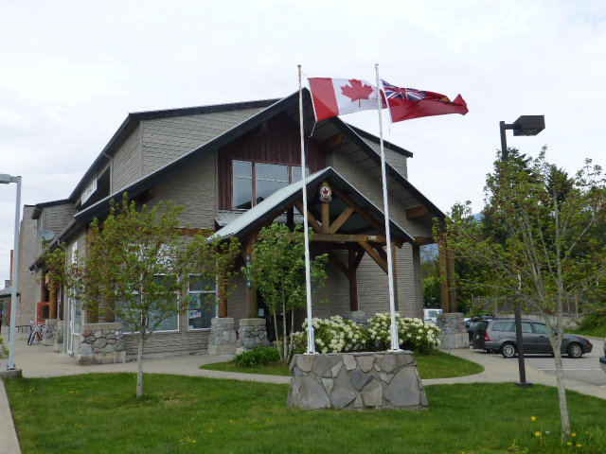

It is the strength and support of the people of Squamish, our partners; and the active Legion membership, that enables RCL Diamond Head Branch 277 to serve our community for the past 85 years.

***The Legion and the Squamish Community***

Diamond Head Branch 277 hosts and sponsors a Veteran/Senior Social Hour at Hilltop House each month.

On a yearly basis*,* RCL Diamond Head Branch 277 donates more than $20,000 to the community.

2015 and 2016 recipients:

* H S Curling Junior Rocks Program
* Griffin 835 Air Cadet Squadron
* Hilltop Support Society
* Hilltop House
* Squamish Food Bank
* Four Student Bursaries of $1000 each.
* Yacht Club Teen Sailing Program
* Veteran Assistance
* Squamish Days Loggers Sports
* BC Children’s Hospital
* Sea to Sky Community Youth Centre
* Legion PTSD Veteran Service Dogs
* Caledonian Black Tusk Pipe Band
* H S Skating Club Junior Program

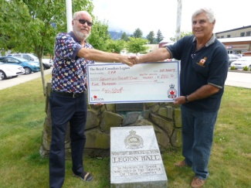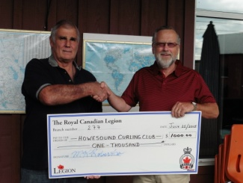

**Picture Left: Ralph Cheswick, (L) receives $500 from President Ken Ward (R) for the Squamish Yacht Club Teen Sailing School 2 week program.**

**Picture Right: Robert Kirkham, (L) receives $1000 from President Ken Ward (R) for the Howe Sound Curling Club Junior Rocks Program.**

***Remembrance in our Community***

Legion #277 is the guardian in leading the Squamish Community during the yearly Remembrance Day Service and laying of wreaths. We “Honour & Remember”!

Each year, Legion #277, along with our Squamish enthusiastic teachers, promotes “Remembrance awareness” to students with the literary and poster contest.

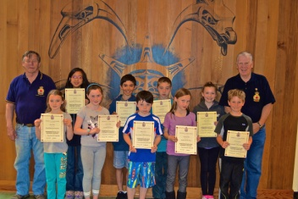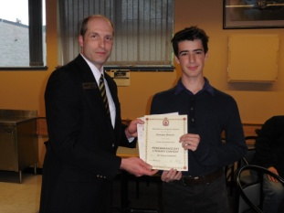

Picture Left (R-L) Garibaldi Highlands Elementary School, Winners of the 2014 Remembrance Day Poster and Literary contest were presented with their certificates and cash prize.  (L) Br 277 Past President, Ed Robertson; (R) Legion member of 50 years, Nelson Winterburn.

Picture Right (R-L) **Zone Commander NSHS, Leo**

**Crossland, presents certificate and cheque to Graeme Bowers for 1st in Zone Intermediate Essay.**

Legion Week in late June of every year provides an Open House to the community and a silent auction to support our veterans.

The 23 “Roll Call of Honour” names with their military stories have been written in the BC/YUKON Command Military Service Recognition Book and can be viewed at the Legion #277 Diamond Lounge.

***Legion and the Veterans***

An appointed Service Officer handles the personal concerns of our local veterans.

Qualifying Veterans are directed to the Veteran Independence Program (VIP**);** aVeterans Affairs Canada program for home support and veteran pension.

Qualifying Veterans receive money from the Poppy Fund for their emergency needs such as shelter, food, fuel, clothing, prescription medicine and necessary transportation.

Legion Br. 277 facilitated two Veteran dinners in 2015; one of which was hosted & sponsored by the River Church.

Several local veterans' stories can be found in the BC/YUKON Command Military Service Recognition Book and can be viewed at the Legion #277 Diamond Lounge.

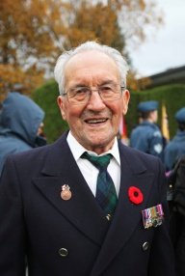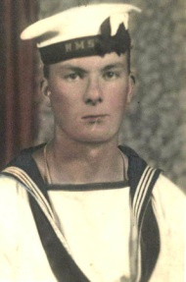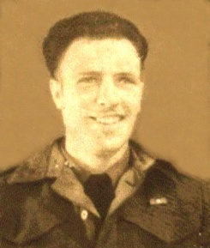

(L-R) Ted Arsenault, James Crombie, Edward Gregoire

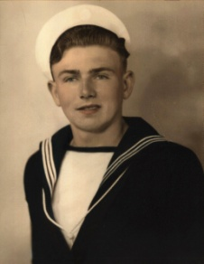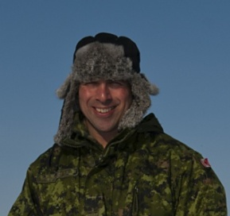

(L-R), Oscar Runzer, Russell Robertson

***In our Community***

A rededication of the **JohnAskey Quick Forest Grove** took place in October of 2012

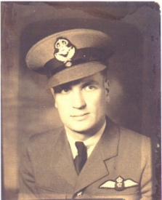

John Quick was the first Squamish youth killed in action during WW11.

He, and several students, planted several arbour trees; after a severe forest fire in the early 1930s. A trail off Government Road leads into Forest Grove where the stone marker and booth exist.

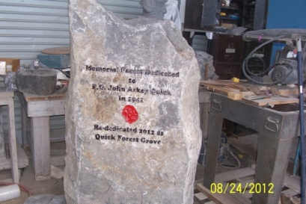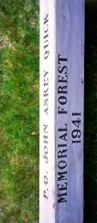

There are 40 Legion Plots at the Mt. Garibaldi Cemetery in Brackendale available to Veterans.

***Membership***

All eligible Canadian Citizens or Commonwealth Subjects are invited to become actively participating volunteer members.

Your membership will be rewarded as being part of an organization that serves its Veterans; promotes Remembrance and serves our community for many years to come.

Come socialize for darts, crib, poker, bridge and Meat Draw at our Legion Diamond Lounge...

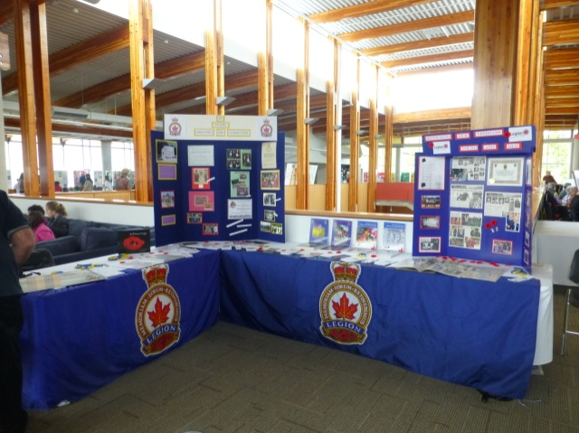

2013 Squamish Culture and Heritage Festival

604.898.9368

RCL Diamond Head Br. 277

Box 1875,

40194 Glenalder Place

Garibaldi Highlands, BC. V0N1T0

[www.squamishlegion.ca](http://www.squamishlegion.ca)

Facebook